Dsa and algo ravindra babu

video1:
asymptotic notations: try to take tightest bound because answers can be more than 1.
f(n) is actual time.

O-big (oh): c.g(n)>f(n) upper bound, g(n) is big O

big omega: c.g(n)<f(n) lower bound, g(n) is big omega

big theta: c1.g(n) <f(n)<c2.g(n) bound from both sides, g(n) is big theta

for every notation always take the leading term with highest power.

Generally:
big oh - worst
big omega - best
big theta - average

video:2

algo : two types 1. iterative 2. recursive. Both can always be interchangeable
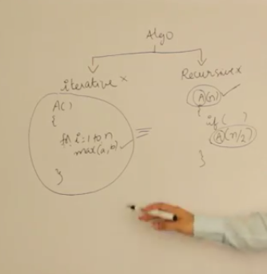

time complexity:

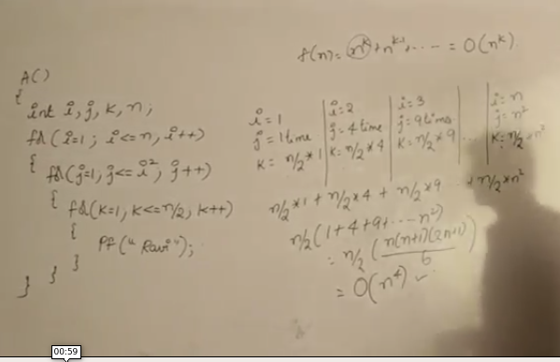

one more example:

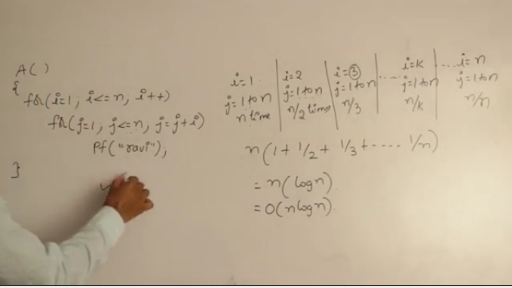

one more example:
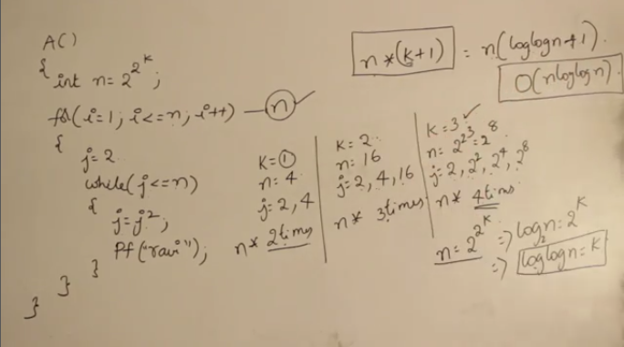

recursive programs time analysis examples:

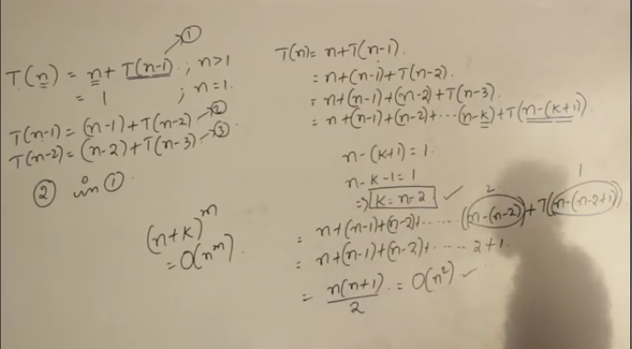

recursion tree method:

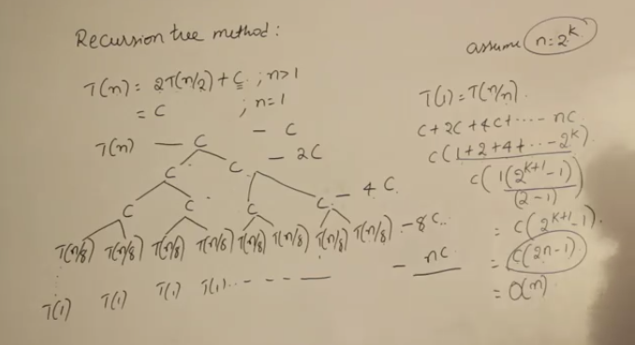

one more example:
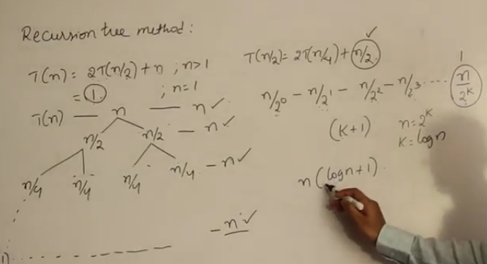

analysising space complexity:

iterative:
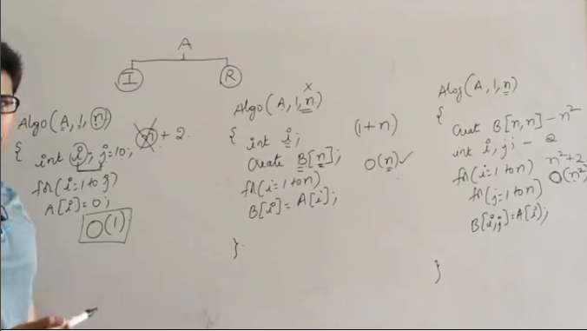

recursive: 1.head recursion 2. tail recursion 3. body recursion

space complexity:

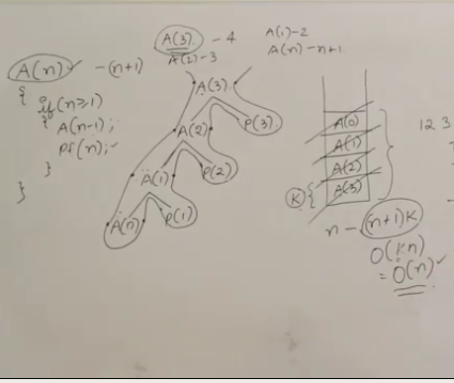

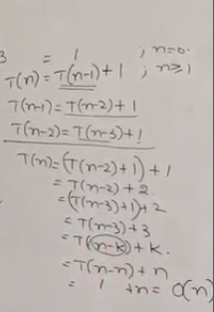

video 7 :

insertion sort:

video 8:

merge sort:
important module was merge
done and dusted
time: O(nlogn)
space: O(n)

video 9:
quicksort
import module was partition
understood , need to write code
continue from video 10

learnt a new thing inbuilt quicksort of stdlib.h

video:11 heap introduction is always a complete binary tree or almost complete binary tree

height of complete binary is h. then total no of nodes = 2^(h+1)-1

if there are n nodes in a complete binary tree then height is floor(log(n))

leaves always starts from [ floor(n/2)+1 to n ]

video 12: max-heapify time complexity O(log n), space complexity because of stack is O(log n)

video 13: build-max-heap time complextity O(n), space complexity is max result of above so O(log n)

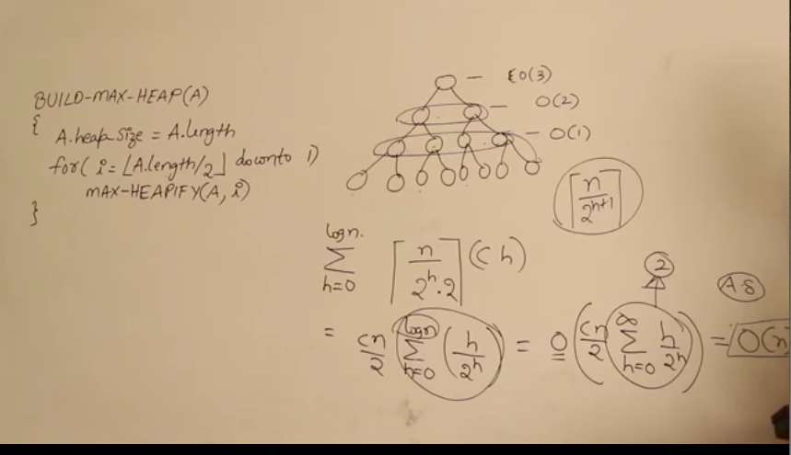

video 14: heap extract max and heap increase key
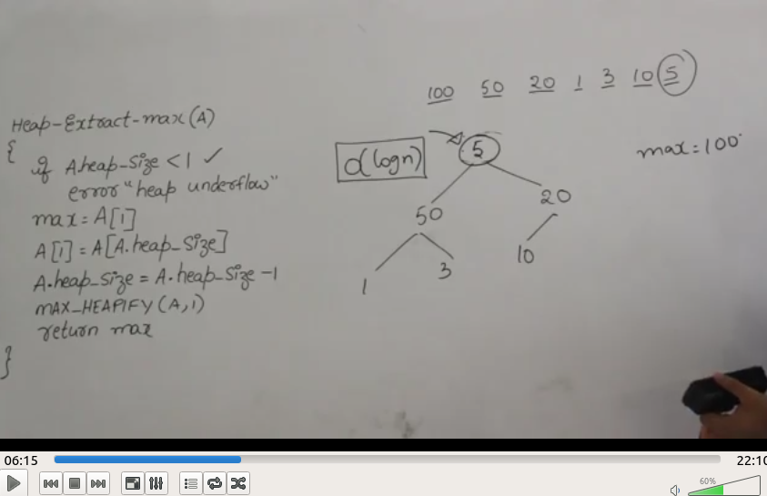

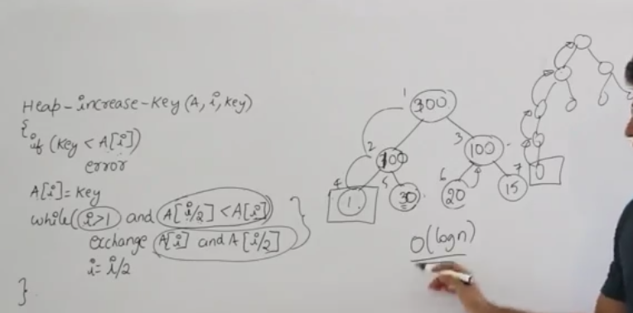

insert key into the heap:

then insert the key at the last position then call max heapify on the last . Time complextity O(n)

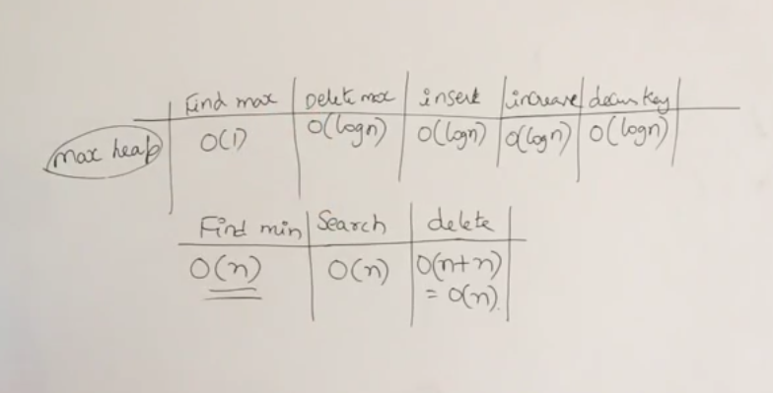

done!

